H34096160 hw5 report

課程名稱：網路最佳化管理

授課教授：王逸琳 博士

1. Environment
   1. CPU: Intel(R) Core i7-9750HF CPI @ 2.60GHz
   2. RAM size: 8 G
   3. HD size: 1 T
   4. OS type: Windows Computer, UNIX by Cygwin
   5. Compiler version: g++ (MinGW.org GCC Build-2) 9.2.0
2. Times of compare
   1. Graph done by Minitab ANOVA imply significant difference between algorithms

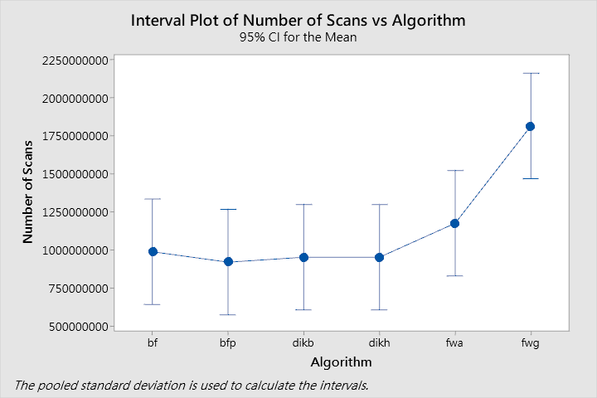

* 1. There are overflow in some cases, I replace it by 1e10(the upper bound of long + 1)
  2. I do not know why comparison time of fwg is largest, and fwa is the second one, but the graph looks OK when n != 1600.

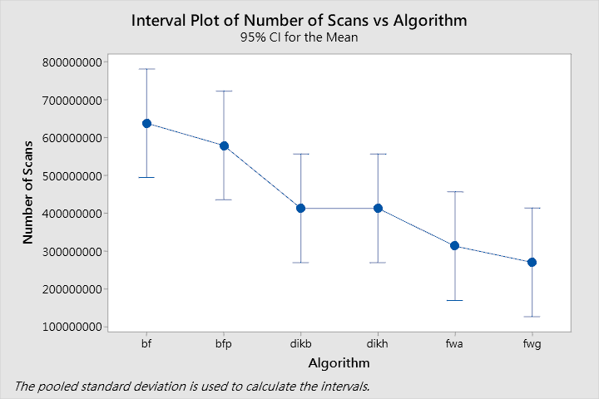

* 1. So I think there may have some problem in large case of my fwg and fwa, but I do not know why.
  2. By plot, I think there have some problem in large case, or the graph looks ok.

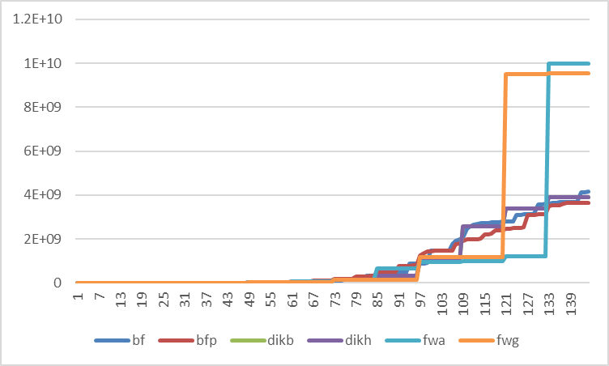

1. Time
   1. Graph done by Minitab ANOVA imply significant difference between algorithms

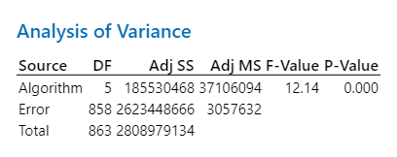

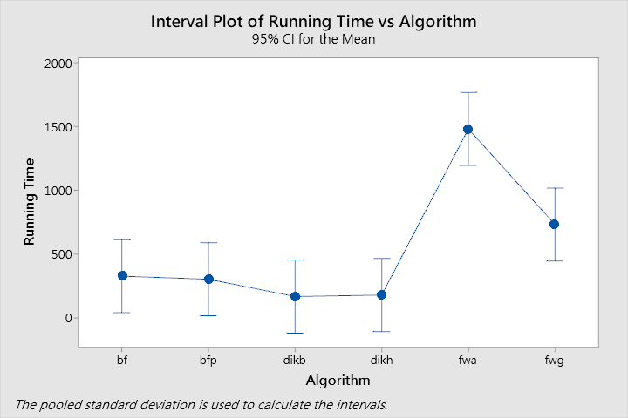

* 1. In this graph, the run time of fwg is much smaller than fwa, this looks OK.
  2. However, 1-ALL algorithm run n times should be larger, but it is not.
  3. I think there are two reasons, one is the difference between C and C++, the other is my coding skill too poor.

1. Else
   1. Input file too large, so I delete it
   2. Use H34096160_hw5_gen.bat to generate it
      1. I do not use seed 1000 because that will make file 192 files, not 144 files
      2. It can run in Cygwin(UNIX), but I do not try in Windows
   3. Use H34096160_hw5_run.bat to run algorithm
   4. Python run on google colab